What "Average Large Optimization Problems" Actually Means?
Problems:
- For a function with a million parameters composed of hundreds of chained operations, hand-deriving the gradient is impossible.
- Average large problems = 100 design variables
Findings:
You can compute the full gradient over all data — no need for mini-batches or stochastic approximations
LU decomposition is practical and fast at this scale — a 100×100 matrix factorizes in microseconds
For your project scope, use full/exact gradients. Stochastic gradients are a future extension, not the current task.

What "100 Design Variables" Problems Actually Look Like
These are not neural network weights. These are physical or engineering parameters:
- Structural optimization — 100 beam thicknesses, cross-sections, or material densities in a bridge or aircraft wing. The objective is to minimize weight while meeting stress constraints. The forward model is a finite element simulation.
- Aerodynamic shape optimization — 100 control points defining an airfoil or car body shape. The objective is to minimize drag. The forward model solves the Navier-Stokes equations.
- Process engineering — 100 reactor temperatures, pressures, flow rates. The objective is to maximize yield or minimize energy. The forward model is a system of coupled differential equations.
- Control systems — 100 controller parameters. The objective is to minimize tracking error. The forward model simulates the system response over time.
Change log:
Your Adam optimizer — Works exactly as-is. 100 variables is nothing for the algorithm. The w0 vector is just length 100 instead of length 1.
Gradient computation options are:
Finite differences
Adjoin method
Automated differentiation

Problem statement generation (used AI)
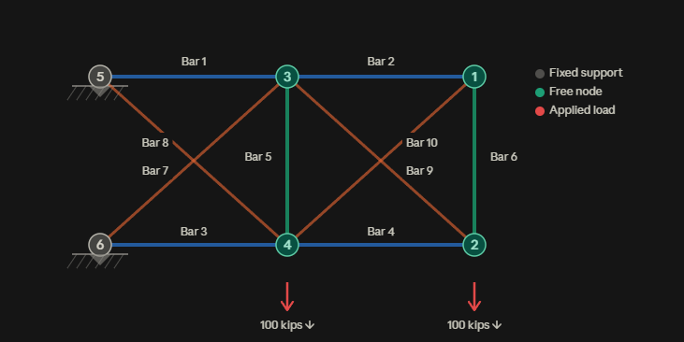
The truss is like a small bridge. 6 connection points (nodes) linked by 10 metal bars. The left side (nodes 5 and 6) is bolted to a wall — it can't move. The right and middle nodes hang freely. Two heavy loads of 100 kips each pull down on nodes 2 and 4.
Each bar has a thickness (cross-sectional area). A thick bar is strong but heavy. A thin bar is light but might snap under stress. Our job is to find the perfect thickness for each of the 10 bars — strong enough to survive, light enough to not waste material.

Scaling it to a 106 variable problem: 6 × 4 grid truss — 106 bars, 35 nodes
